**Ecosystems of Poland**

Learn about the ecosystems of Poland.

Instructions: Select an ecosystem from the map by clicking on it. Then move your mouse over the images of the flora and fauna in the picture to learn more about them.

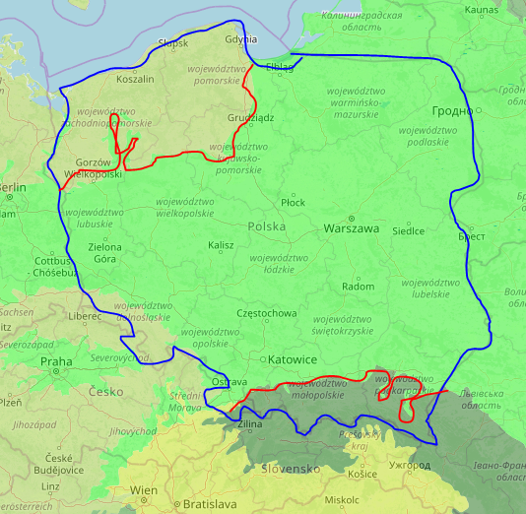

**Carpathian Montane Forests**

**Baltic Mixed Forests**

**Central European Mixed Forests**

Source: <https://worldmap.harvard.edu/maps/6046>

**Region 1. Baltic Mixed Forests**

This ecoregion consists of both forests and wetlands. Its proximity to the Baltic Sea attracts a large number of migrating shore birds and wading birds.

**White-tailed Eagle (Haliaeetus albicilla)**

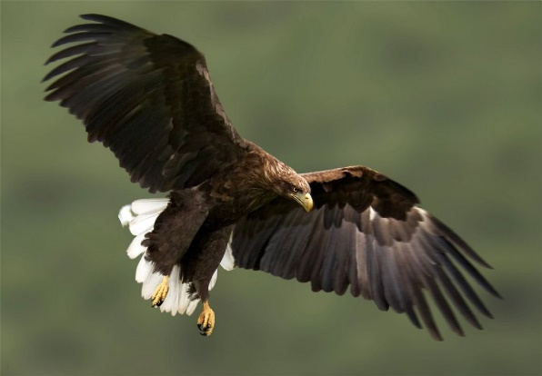

https://upload.wikimedia.org/wikipedia/commons/thumb/0/08/White-tailed_Eagle_34.jpg/220px-White-tailed_Eagle_34.jpg

* + This sea eagle is closely related to the North American bald eagle. It is believed to be the eagle pictured on Poland’s coat of arms.

**Marsh Labrador Tea (Rhododendron tomentosum)**

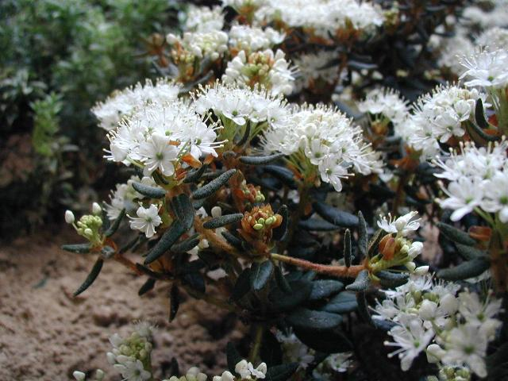

https://upload.wikimedia.org/wikipedia/commons/thumb/e/e8/Rhododendron-palustre.JPG/220px-Rhododendron-palustre.JPG

* + This shrub’s leaves can be used to make a weak herbal tea, which has been traditionally used for the treatment of rheumatism, cough, cold, and insect bites.

**European Fire-bellied Toad (Bombina bombina)**

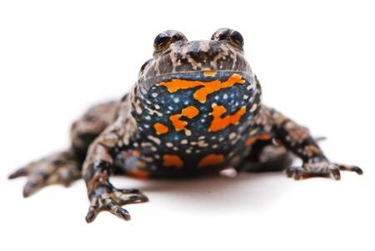

https://www.google.com/url?sa=i&source=images&cd=&ved=2ahUKEwiJ3-z5-KTnAhVCJDQIHbpZDCoQjRx6BAgBEAQ&url=https%3A%2F%2Fwww.123rf.com%2Fphoto_16555655_bombina-bombina-european-fire-bellied-toad-on-white-background-.html&psig=AOvVaw1VNPCaYI10Wi55vHPluluu&ust=1580254494876051

* + This small toad gets its name from its colorful underside, which it may expose to potential predators. When threatened, its skin may also secrete toxins.

**Eurasian Beaver (Castor fiber)**

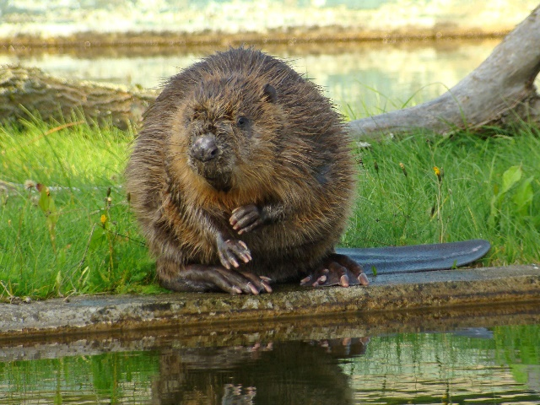

https://i.pinimg.com/originals/80/b2/48/80b248bbe9d6d262afc51da9e521270d.jpg

* + After World War II, the beaver was nearly extinct in Poland. Since the 1970s, beavers, now a protected species, have been reintroduced into Polish wetlands.

**Water Lobelia (Lobelia dortmanna)**

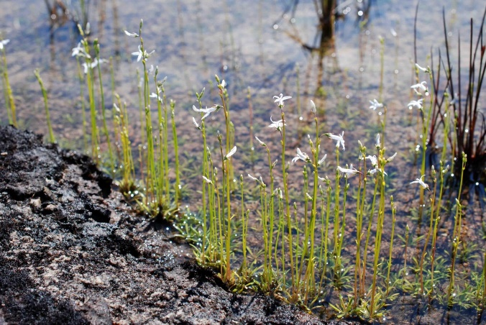

https://www.centralcoastbiodiversity.org/uploads/1/4/9/9/14993002/3046175_orig.jpg

* + These sensitive water plants indicate the quality of water within lakes, as they only grow in exceptionally clear, nutrient-poor environments.

**Region 2. Central European Mixed Forests**

This ecoregion’s forests are located in hilly moraines to the north, vast plains in the middle, and upland regions to the south.

**European Bison (Bison bonasus)**

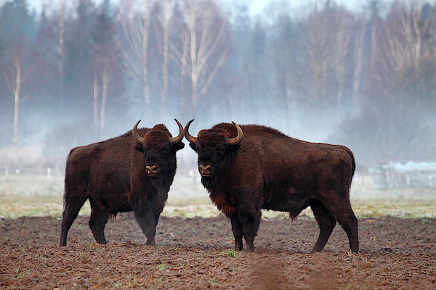

https://render.fineartamerica.com/images/rendered/default/phone-case/galaxys8/images-medium-5/3--bison-bison-bonasus-in-bialowieza-david-santiago-garcia.jpg?&targetx=0&targety=-28&imagewidth=620&imageheight=413&modelwidth=620&modelheight=356&backgroundcolor=8B6D61&orientation=1

* + - The European bison became extinct in the wild after World War II but has been reintroduced in eastern Poland. It is Europe’s heaviest land mammal.

**White Stork (Ciconia ciconia)**

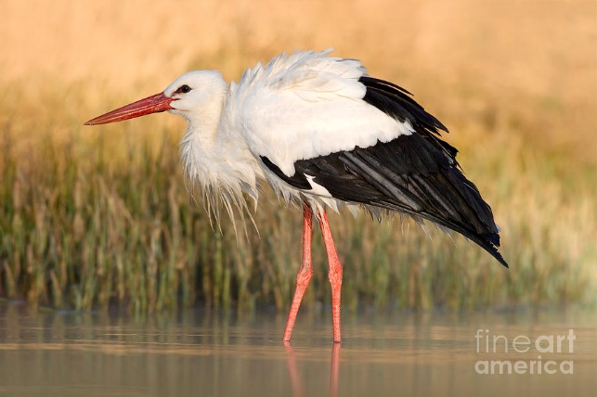

https://images.fineartamerica.com/images/artworkimages/mediumlarge/2/white-stork-ciconia-ciconia-in-the-ondrej-prosicky.jpg

* + Each year roughly 25% of the world’s storks nest in Poland, where they are a protected species and considered a symbol of good luck.

**European Adder (Vipera berus)**

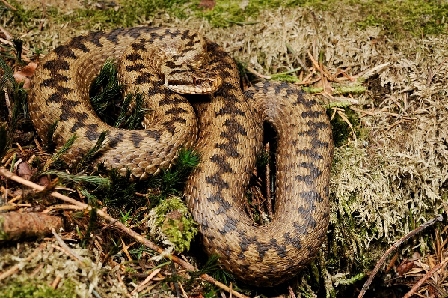

https://upload.wikimedia.org/wikipedia/commons/thumb/d/dc/Benny_Trapp_Vipera_berus.jpg/1200px-Benny_Trapp_Vipera_berus.jpg

* + - The adder is Poland’s only naturally occurring venomous snake. Its bite, while painful and likely to cause a rash and swelling, is very seldom fatal.

**Common Yew (Taxus baccata)**

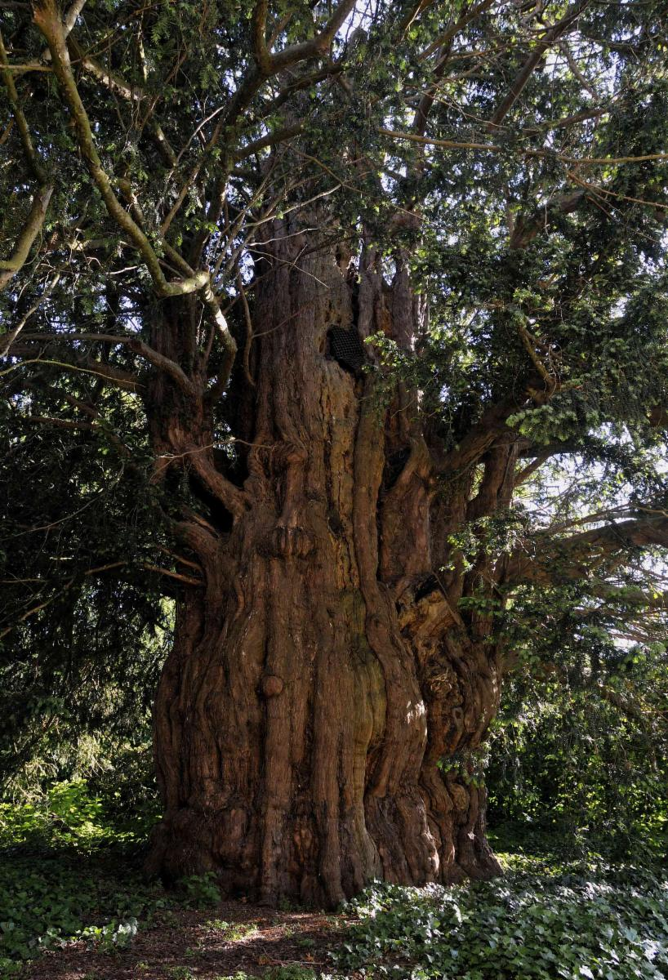

http://storage.googleapis.com/powop-assets/kew_profiles/KPPCONT_028885_fullsize.jpg

* + This shade-tolerant tree, often found as undergrowth below the forest canoy, is protected within Poland. The seeds within its berry-like seed cones are poisonous.

**Bat (Myotis spp., Eptecisus spp., and others)**

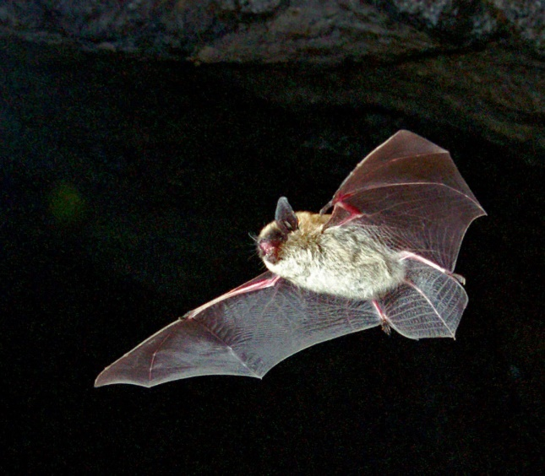

https://files.ontario.ca/esfm-rs-1.jpg

* + - Over 30,000 bats winter in Nietoperek, the largest underground bat refuge in Europe. The Nietoperek tunnels were originally part of Nazi Germany defensive fortifications

**Region 3. Carpathian Montane Forests**

In the high mountains to the far sou,th live some of Poland’s most distinctive species. Poland’s largest predatory species also make this region their home.

**Laserwort (Laserpitium archangelica)**

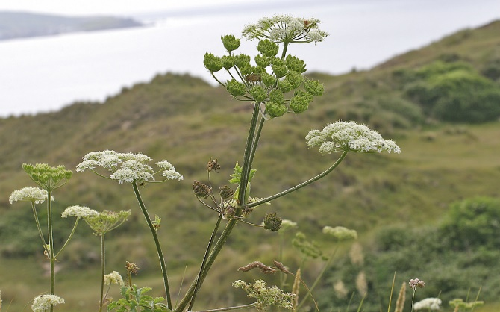

http://www.lepi-photos.com/uploads/7/9/4/2/7942661/1316292_orig.jpg

* + - Laserwort is one of Poland’s few endemic plant species and has several medicinal uses. It is only found in Babiogórski National Park in southern Poland.

White Stork Place here if needed, otherwise keep ithe n previous position

**Gray Wolf (Canis lupus)**

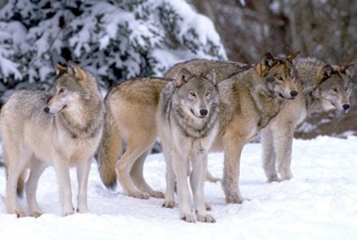

http://www.cosmosmith.com/images/wolfpck2.jpg

* + Wolves have been a protected species in Poland since 1998. They primarily prey on deer, but domestic livestocisre also sometimes lost through wolf attacks.

**Brown Bear (Ursus arctos)**

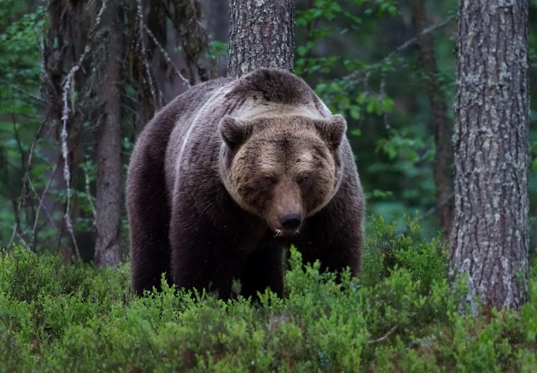

https://live.staticflickr.com/1825/29058988558_88706db777_b.jpg

* + Poland’s bear population has increased in the southern mountains since declining to 10–14 individuals in the 1950s. Reports of bear attacks on humans are rare.

**Chamois (Rupicapra rupicapra tatrica)**

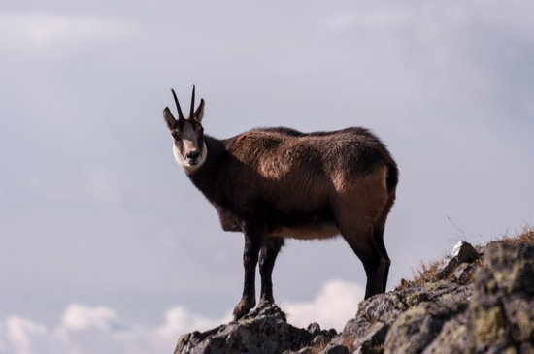

https://marketplace.canva.com/MADFV-hy3qg/1/thumbnail_large/canva-tatra-chamois-%28-rupicapra-rupicapra-tatrica-%29-MADFV-hy3qg.jpg

* + This subspecies of the goat-antelope is native to the Tatry Mountains. Its population is still severely threatened after nearly being hunted to extinction.